**Dynamic single-handed text string input interface**

*(Last updated 12/27/12)*

Alexander Cihla and Sandy Diao

**Field of the invention-**

This invention relates to the field of data input on touchscreen devices. The invention aims to optimize factors related to ease of use, accuracy, and speed for single-handed operation.

**Description of the related art-**

Standard QWERTY keyboards and other keyboard layouts are not optimized for quick and easy use, especially on the increasingly large screens of modern mobile devices. True one-handed use of a cellular device is nearly impossible. Often, a user must use one hand to stabilize a mobile device while the other hand is used for actual interaction with the data input medium. Text input on tablets and other touch screen devices also requires a user to poke at the screen or traverse a substantial distance between characters, thus making typing, texting, and other data input methods a tedious chore.

**Brief description of the invention**-

A circular/oblong interface with the ability to change location, size, and angle provides a more efficient and ergonomically friendly design. Enabling users to customize placement and size will aid in optimal ease of use while also adapting to the background situation and maximizing visibility to context of the data input situation (ex., Email, texting, web browsing, social media sites, blogs, etc.). Allowing users to use continuous gestures to select characters aids in the fluidity of data input. Traversing the circular design not only minimizes physical distance between characters and symbols, but also takes advantage of a smaller space while still providing the affordances of an easily explored shape(easy for use with a single finger).

This technique of data input on mobile devices minimizes learning curves between different devices while also being affording the most natural of finger movements. The dynamic placement and size coupled with the circular/oblong shape make this the optimal tool for one-handed data-entry.

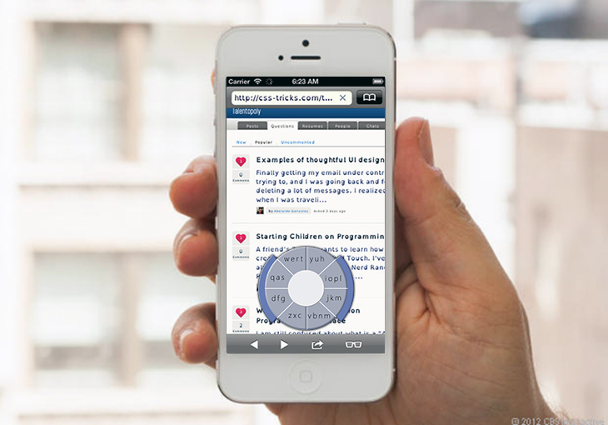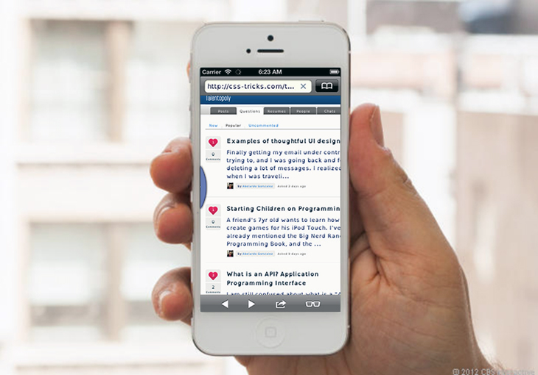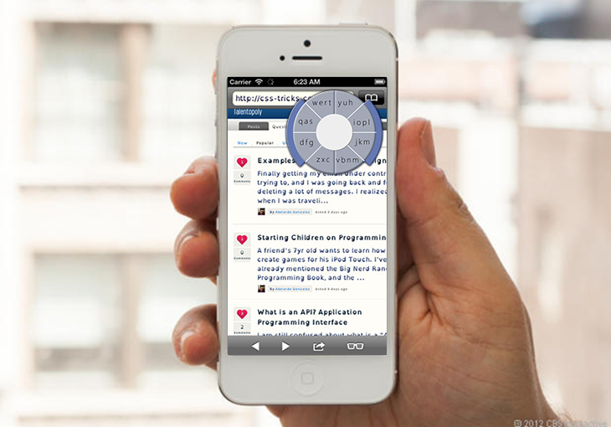

**Figure 1.**

To change size and location of interface area: double tap the neutral zone (core of compass) and hold then drag to desired location, use two finger stretch/shrink, and two finger rotations. When alterations are over tap outside the compass area.

Text may wrap around input area or remain static when new location is set. One may also select a button or mode that signals active manipulation of the input area. Other possibilities include various combinations of physical gestures, voice commands, or simple switches.

**Hiding the keyboard**

Take the interface off-screen by placing a finger on the right bumper and intuitively sweeping the entire keyboard off the screen to the left. What will be left on the screen is the edge of the tool, and you can pull it out at any time by putting your finger on the edge and pulling the keyboard back on the screen.

**Neutral zone**

The text input design includes a central area we call the “origin” that acts as our reference point. It can be set to give physical or audible feedback to the user when tracing over it in order to give a sense of location and aid in “no-look” texting. Once a user enters the target area of the origin, the phone can buzz, vibrate, beep or otherwise signal to the user that they are currently at the center of the text input zone and can therefore trigger the user to pivot and traverse the input area to the next grouping or character of interest.

Clicking on and holding the origin of the texting device will allow the user to then drag and manipulate the size, shape, rotation, and/or location of the text input area. A short tap on the origin (center of the circle) could signal the use of a period.



**Figure 2.**

**Bumpers**

The north, east, south, and west bumpers of the design have many possible uses. The most appropriate of which are as follows:

* Pressing on or near the south bumper then dragging to the north bumper will signal the change of our characters to their uppercase form for the character immediately following this action. Holding this gesture at the top acts as a sort of Caps Lock. To reverse this we simply do the opposite by swiping from north to south.
* For deleting a character to the right of the cursor swipe from west to east and to delete a character to the left we swipe east to west. To delete all characters in a continuous string (no white spaces), we use the same gesture but hold it at the end of the gesture, similar to the way in which we activate Caps Lock for the other bumpers.

**No bumpers**

Without these bumpers we can still imagine their existence and use similar, intuitive movements or gestures to accomplish these tasks. For example, a quick shake of the device could delete the current word and a long shake could delete the entire entry.

*Other examples:*

* A curved movement from top to bottom or bottom to top could symbolize a parentheses depending on the bend.
* Two simultaneous taps can signal colon.
* Slanting swipe signals a slash.
* And other symbols can be signaled in similar ways (gestures that can be easily recognized as symbolizing a certain shape, punctuation mark, and/or symbol)

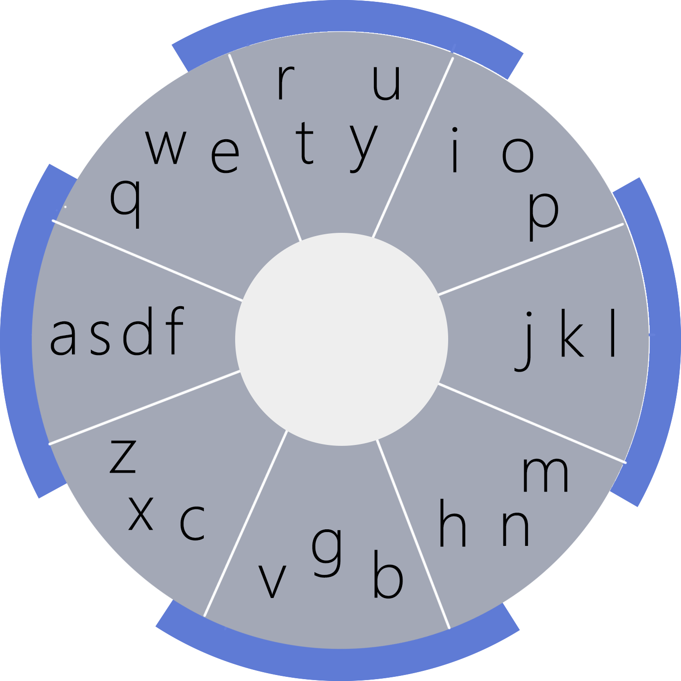 

**Figure 3.**

**Groupings**

This approach aims to simplify the user input dilemma. By grouping characters the user only needs to remember the mapping between characters and their respective sections of the user input area. Manipulation of these groupings can then supply a sequence of possible letters used which is then further analyzed to suggest the most frequently used word or estimate word based on context. Having a user tap individual groupings or swipe from group to group will allow for the system to interpret the user’s selections and then output the most appropriate word choices for the user to chose from.

There can be a vast number of groupings but a minimum of four buttons is needed. The main point of groupings is to minimize the number of individual buttons a user must remember so the less the better when considering this goal alone. The example shown in Figure 3 is based on the physical layout of a QWERTY keyboard and will therefore help to minimize any possible learning curve so that users can easily remember what letters belong to what groupings. Non-QWERTY related groupings can group based on letter type, shape, frequency of use, or any other organizational method that helps to balance and optimize accuracy, efficiency, speed, and ease-of-use.

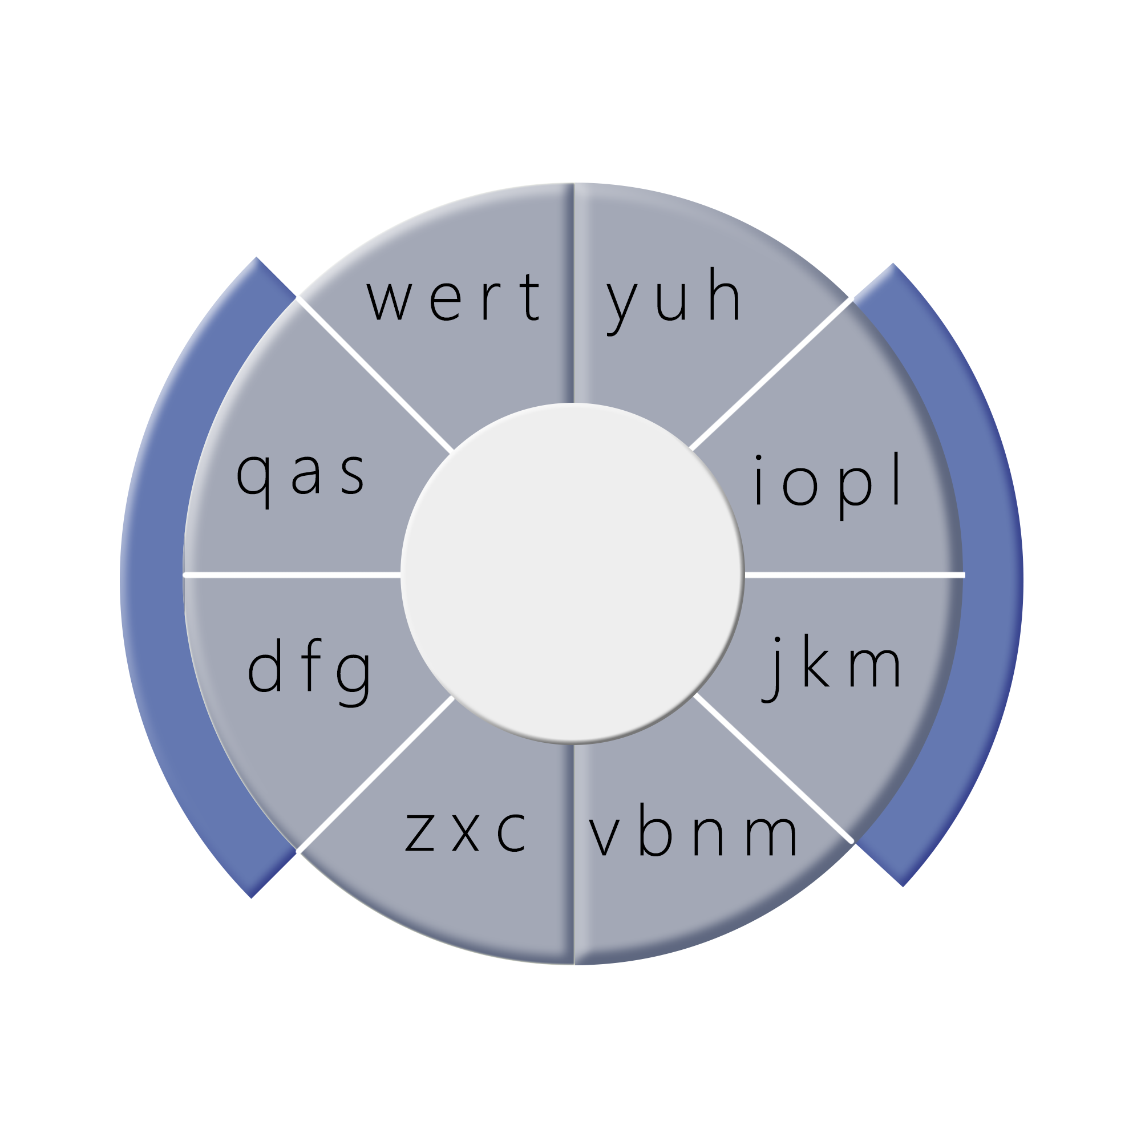

**Figure 4.**

Figure 4 illustrates another possible grouping combination. Using more or less groupings is a possibility but the main goal here is to optimize and find a balance between ease of use, minimal learning curve, accuracy, speed, and overall performance and functionality. Another example of a plausible grouping scheme is one based on the fingers that are usually used to input each character on a full, standard QWERTY keyboard.

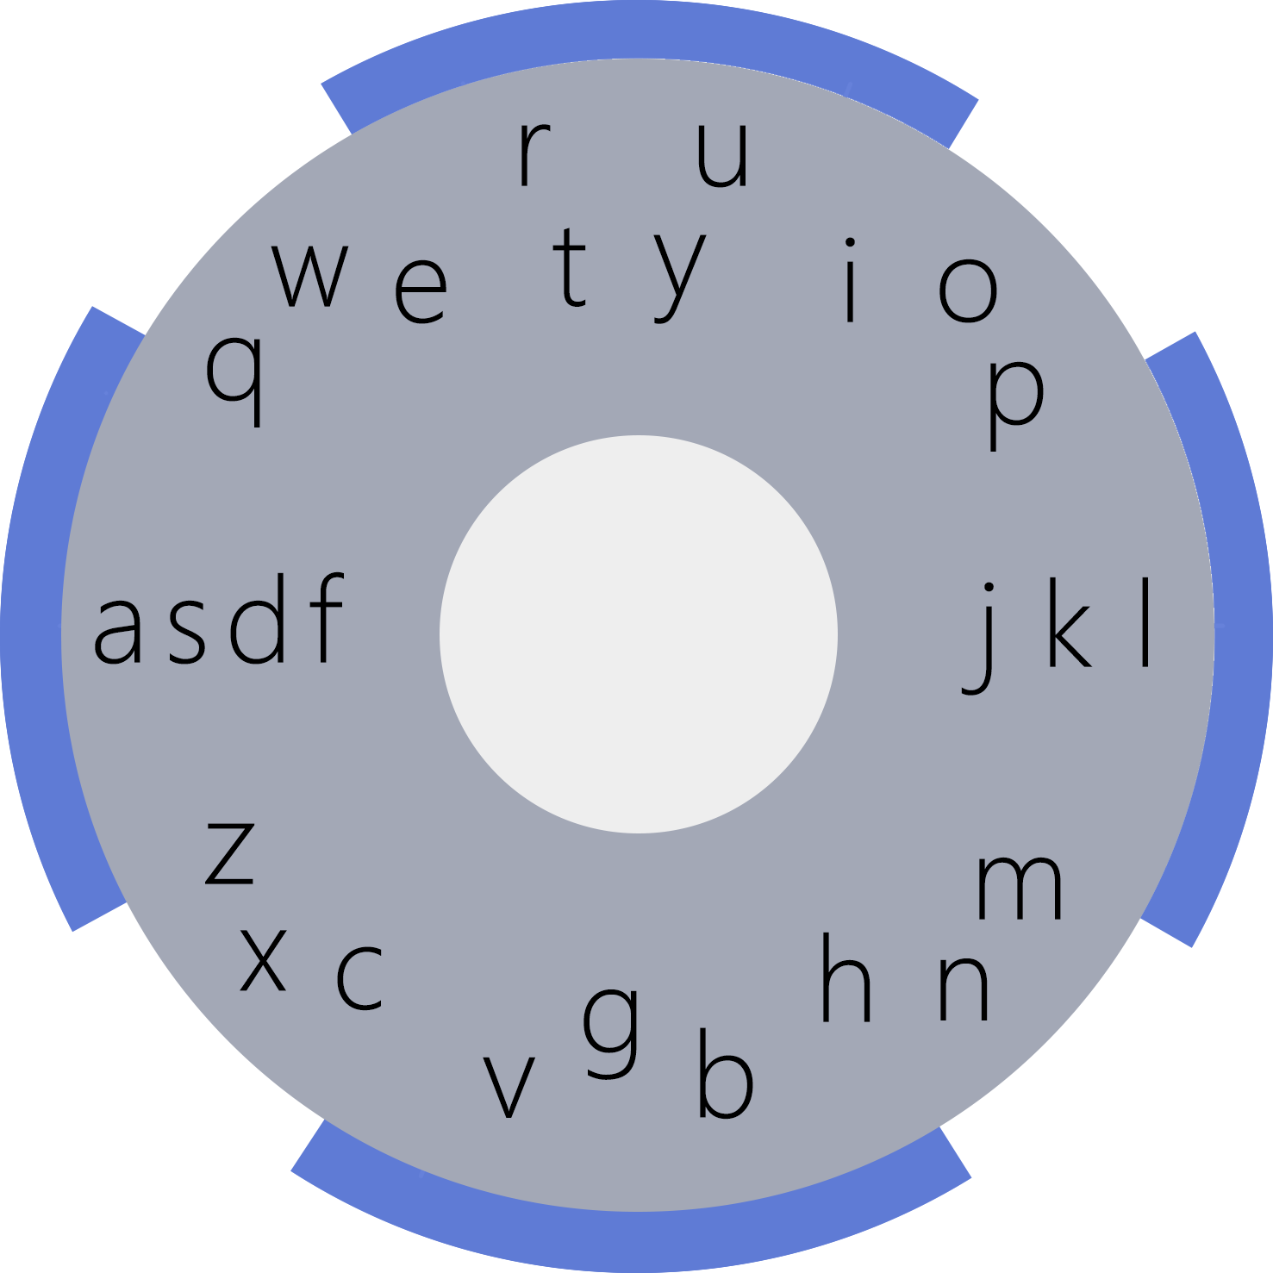 

**Figure 5.**

**No groupings**

Fig. 5 illustrates the use of invisible delimiters (that not necessarily static) to map how close a user’s tap or swiping gesture comes to a given sequence of characters. To allow for optimal accuracy it would be possible to shrink the character “trigger” size (or make it bigger) based on predictive technologies and estimating what character is most likely to come next in a given sequence.

We can use a QWERTY based layout here or a different organization based on frequency of use for each character, Dvorak, or some other organization to optimize/balance accuracy, efficiency, speed, and/or ease-of-use.

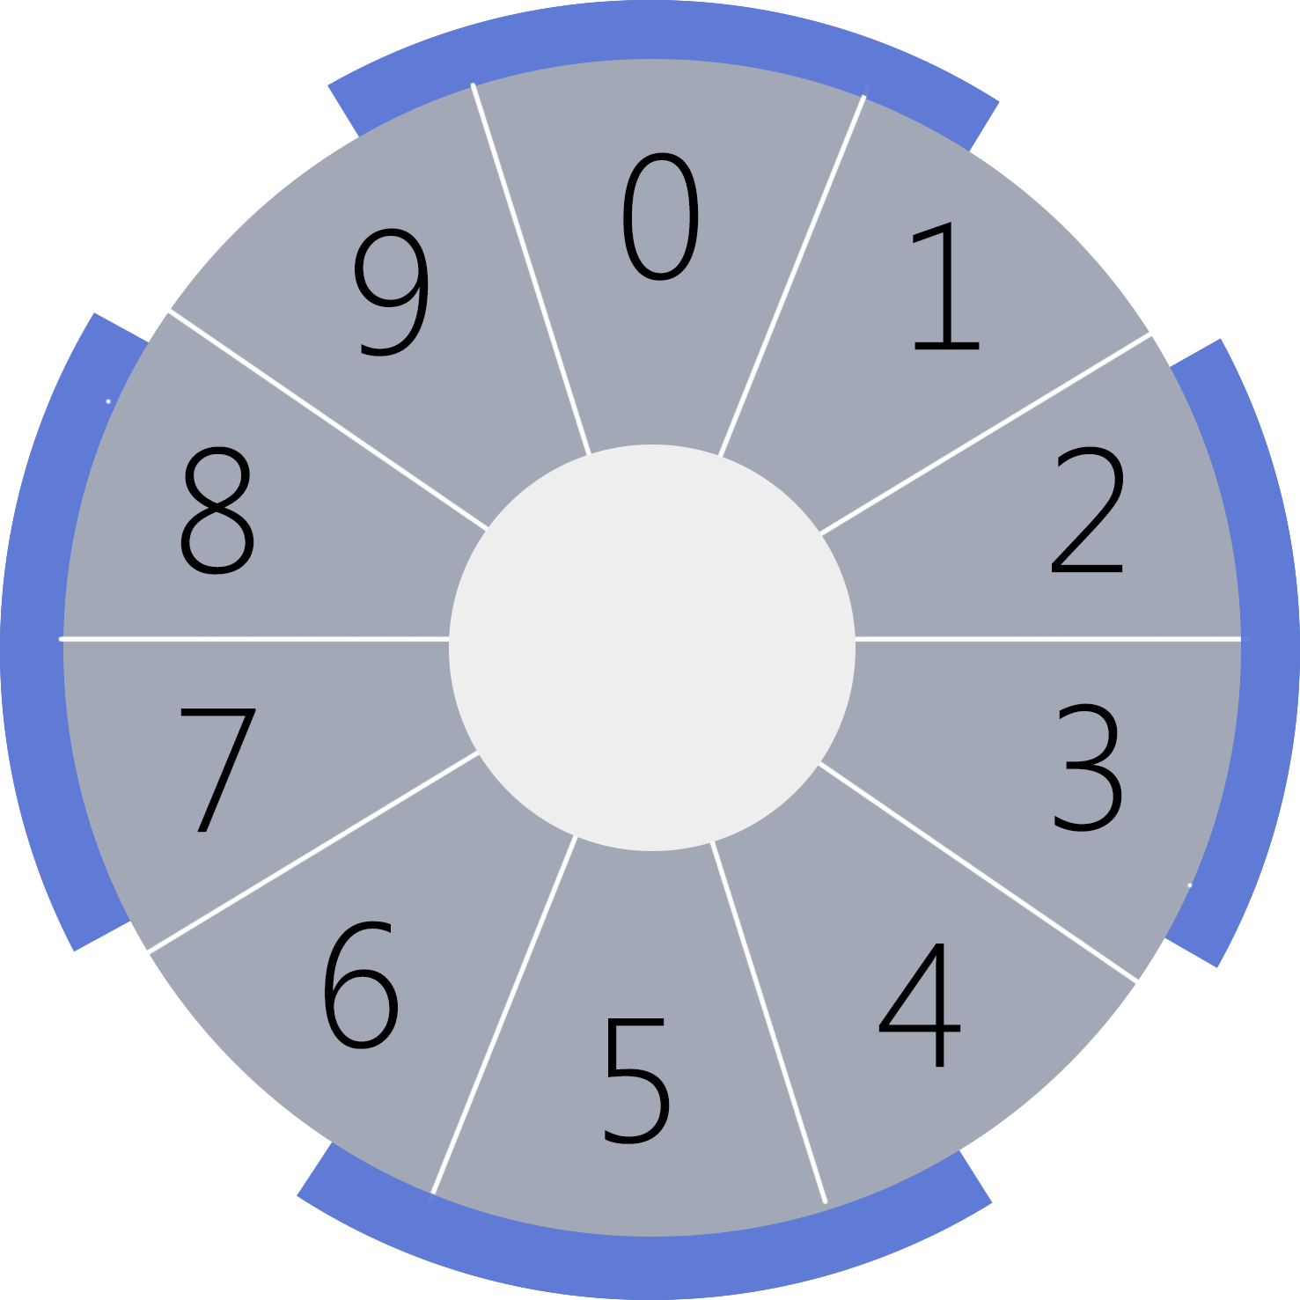

**Figure 6.**

**Other gestures**

Swiping around or within the circumference of the input area in a speedy and continuous manner will bring up a number and symbol mode where groupings include numbers and/or symbols, which can then be selected by the user. Fig. 6 illustrates the numbers mode. In order to return to the character-focused display, the user glides across the partial circumference again. The shape, length, and speed of this gesture will need to be specified in order to minimize accidental triggering while also making it easy to trigger when the user wants the aforementioned task to occur.

Symbol input can be accomplished through two potential means. Drawing the shape of the symbol using a finger to input the character is a method that requires no learning. Hitting a bumper or other type of switch is a possible trigger drawing mode. The user can use a finger to make out the shape of the symbol to the space next the keyboard. Another method is inputting symbols on the basis of the number of strokes. Ex., a colon, semicolon, and exclamation mark all have two strokes. When you tap the center of the Compass’ circle, you tap twice to open up a keypad of all relevant symbols and punctuation with two strokes.

Selecting individual characters/symbols can be done in various ways. One of which is a quick succession of taps on a single grouping to select a given character within the grouping (based on its location from left to right). Ex. For the grouping “ABC” use two taps for B and one for A. A tap-and-hold movement or other trigger will select the character and continue with the input process.

Another possibility is normal swiping/ continuous gesture where the user signals for further expansion of each grouping. A pause or other gesture on a given grouping would then expand the grouping into separated character keys which can then be selected by the means of further continuous movement and pivoting or passing through of the targeted character. Leaving the “magnification” of said grouping would then bring the user back to the standard text input layout and they can continue on by pausing at another grouping and further specifying the target character.

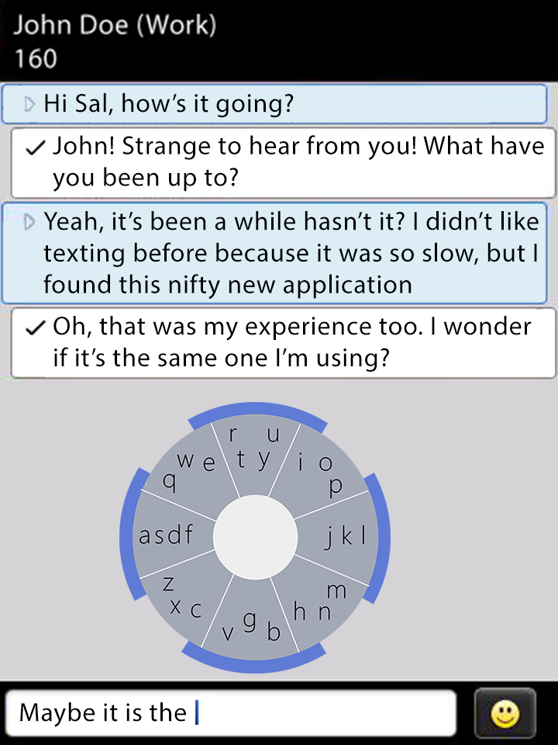

**Figure 7.**

Fig. 7 illustrates an example of the possible context of use. Texting, one of the most common forms of data input on mobile devices would likely find this compass-like design very useful and easy to use.

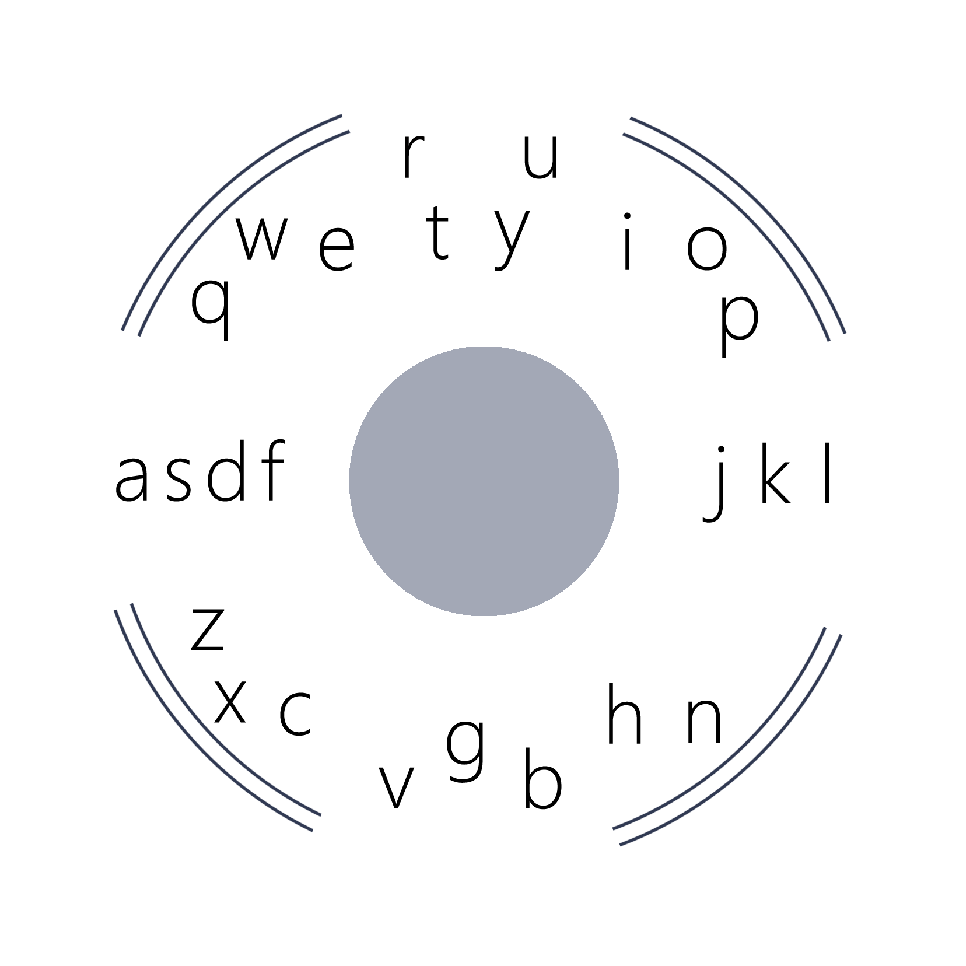 

**Figure 8.**

**Other iterations** *(see attached sketches)*

Futuristic and advanced design for those already comfortable with locations and groupings. The figure on the right can be used as a transparent interface that can overlay material of interest without interfering with visuals. Other “compass-like” appearances can be used to minimize the visual impact of the data-input tool while maintaining full functionality.

Markers to give the user a sense of direction (up, down, north, south, etc.) are retained so that the groupings or character layout can still be visualized by the user.

**Advanced Input**

Once users have learned the Compass, they can choose to turn off the letters and only view the grouping modules. At a more advanced stage, users can turn off the colorings to use an opaque keyboard with only the center circle and skeleton outlines of the groupings in order to get more screen space and more navigability.

**Dynamic Positioning of Input Area**

Start

Dynamic positioning and customizability mode triggered

User input in the form of gestures

New location, shape, size, angle, and other aspects of interface set

User triggers the end of dynamic mode

New attributes set and saved for future use

End

**Figure 9.**

**Data Input via user Actions** (work flow)

Start

Data input mode triggered and input interface is live

Gestures such as continuous touch (swiping, gliding, etc.), tapping, or other gestures

Sequence of character/groupings collected based on type of input action performed

Continuous touch gesture (swiping, gliding, etc.)

Short tap

Extended pause on a given grouping

Groupings/characters selected by start, end, and pivot points. Other traversed groups/characters included if deemed intentional

Groupings/characters selected by individual taps on/near target area

Expansion of grouping to allow for explicit character selection

Suggestions/predictions calculated and presented to user for selection based on hybridized prediction

Word selected. Space inserted and ready for more input

Error. No word found

End

Send or submit data

**Figure 10.**

**Educated Word Suggestions**

Start

Sequence of characters via possibilities of groupings and/or individual characters

Contextual Queues (ex. Situational, speed of entry, probability of user mistake, proximity to other options, etc.)

Standard Dictionary

Preset profile dictionary (ex. Medical, professional, adolescent. Etc.)

Personal profile dictionary (ex. Previously used words)

Aggregate frequency of use/ likelihood of use

Presentation of possibilities/suggestions ordered by most likely to be used

Word selected. Space inserted and ready for more input

Error. No word found

End

Send or submit data

**Figure 11.**

**Educated suggestions and contextual parsing**

Start

Synch with emails, text conversations, social media sties and parse messages to update personal dictionary

Data input interface activated

If context is not loaded or known then parse current situational context for words and phrases to add to temporary/contextual dictionary

Input interface ready and commence with user input

End

**Figure 12.**

**Word Selection**

The sequence of buttons tapped, pivoted on, and/or passed through (the last two are for cases of continuous selection motion—swiping/gliding over groupings) will correspond to a collection of possible words ordered by a combination of a standard frequency of use within the particular language, frequency of use for the individual, contextual clues based on previously selected words in the current situation, and contextual clues based on context of task (ex. Texting partner’s messages, email one is replying to, a webpage currently commenting on, etc.).

The trigger area of each character/grouping can be dynamic. Meaning that the input application will intelligently decipher what group or character a user meant to select based on their previously input characters and the same rubric used above. This could mean that certain trigger areas shrink, grow, or the selection process is altered (ex. Instead of considering a character or grouping that was passed through we will only consider the character or grouping that we pivot at or end on, etc.)

Speed of use and interpretation of a “hurried” versus a “cautious” user will also weigh in on the plausibility of mistakes in character/grouping selections. Generally, the faster someone attempts to use the interface the more selection power that will be given to the input system to decide what word the user is attempting to input.

Word options (possible outcomes of character selection) can be shown on a bar either at the top or bottom of the screen to allow user to select desired word. A scrollable banner can be position anywhere on the screen while balancing a minimization of visual interference while also making it easy for the user to find and select a target word.

The input system can learn and adapt to a user’s particular language use and style. It is possible to have preloaded dictionaries correlated with different pre-loaded profiles. For example:

* Medical profile: highly rated frequency of use for medical jargon and technical terms, eliminate profanities, etc.
* Teenager profile: highly rated frequency of use for common sayings and slang, includes profanities, includes current pop culture references, collection of frequently used words among friends and frequent contacts as opposed to that of a single individual
* Professional profile: no profanity, technical terms, educated-auto-corrections/recommendations (cautious to not use slang, informal language in a conversation that has never included slang or improperly punctuated sentences before)

The list of examples can be expanded as much or as little as necessary to optimize ease of use for a wide range of customers.

**Related Application**

Another possible use of this user interface is for data input on the back of a mobile device. A feasible iteration of this application could potentially use a built in touch-sensitive screen or an aftermarket modification such as a case, or other fitting alteration, with a built-in screen (capacitive or otherwise). The user would then be able to view the input area on the front of the screen and also view the point of pressure (or center of touch if capacitive) being applied to the back of the screen. From here a user would be able to trace from characters/groupings in a very similar fashion as that described in the aforementioned specifications.

The improvements offered by data input interfaces moving to the back of devices would include the minimization of interference to screen content from fingers/hand of user as well as the possibility of optimizing ergonomic functioning and overall ease of use.

Tablet use of this circular/oblong design may afford the use of two hands. In which case it is important to realize the importance of the rounded input area and simplified groupings/placement of characters described earlier. It may be more convenient to split the interface into halves so that both hands can be active in the data input functionality. Retaining the rounded design, groupings, dynamic positioning, word selection, and educated suggestion system previously described will be vital whilst possible segmentation of the interface area will help to make use of an unburdened hand.

**References**

Adjusting Keyboard 5748512 <http://www.google.com/patents/US5748512?dq=7098896&ei=K8XWUL6RH8KbjAKh5IGYAw>

Off-center key selection for standard keyboard, differentiates between keys pressed at same time or keys pressed off-center

Dynamic Predictive Keyboard 5128672

<http://www.google.com/patents/US5128672?dq=7098896&ei=K8XWUL6RH8KbjAKh5IGYAw>

Has ability to predictively display different characters in association with its various keys within a variety of predefined character set layouts

Character string retrieval system using index and unit for making the index 5357431

<http://www.google.com/patents/US5357431?dq=7098896&ei=K8XWUL6RH8KbjAKh5IGYAw>

Document/text/email data searching application (we could use it here for our smart/historic texting prediction)

Method for data input on a touch-sensitive screen 5574482

<http://www.google.com/patents/US5574482?dq=7098896&ei=K8XWUL6RH8KbjAKh5IGYAw>

Frequency of use ordering and either tap or continuous movement gestures for selection. Other gesture based text-input specifications (space, capitalization, etc.)

Keyboard with one hand character key array and one hand character mapping key array 5006001

<http://www.google.com/patents/US5006001?dq=7098896&ei=K8XWUL6RH8KbjAKh5IGYAw>

One handed text input… for mechanical purposes. Not very relevant

Improved method and system for entering text with an on-screen keyboard 6008799

<http://www.google.com/patents/US6008799?dq=7098896&ei=K8XWUL6RH8KbjAKh5IGYAw>

Gesture uses with N,W,E,S movements and tapping gestures to select characters/words

Smart multi-tap text input 7382359

<http://www.google.com/patents/US7382359?dq=7098896&ei=K8XWUL6RH8KbjAKh5IGYAw>

Analysis of time on gestures and selection actions to disambiguate character/word selection

Reduced keyboard layout that emulate QWERTY-type mapping and typing 7202853

<http://www.google.com/patents?id=pSyEAAAAEBAJ&printsec=abstract&zoom=4#v=onepage&q&f=false>

Groupings based on QWERTY layout but optimized for 2 hands

Compact touch-type keyboard 8194040

<http://www.google.com/patents?id=eIIdAgAAEBAJ&printsec=abstract&zoom=4#v=onepage&q&f=false>

a button of a size appropriate for comfortable operation by a finger, while allowing the selection of a large number of functions in a space… silly moving circles text input idea

|  |
| --- |
| [US7679534](http://www.google.com/patents/US7679534?dq=7098896&ei=K8XWUL6RH8KbjAKh5IGYAw)  Jun 10, 2004  Mar 16, 2010  Tegic Communications, Inc.  Contextual prediction of user words and user actions (and those that reference this particular example)  [US7712053](http://www.google.com/patents/US7712053?dq=7098896&ei=K8XWUL6RH8KbjAKh5IGYAw)  Jun 20, 2002  May 4, 2010  Tegic Communications, Inc.  Explicit character filtering of ambiguous text entry  [US7227536](http://www.google.com/patents/US7227536)  Apr 28, 2003  Jun 5, 2007  Research In Motion Limited  Hand-held electronic device with a keyboard optimized for use with the thumbs (same goal but with different solution/idea)  [US5847697](http://www.google.com/patents/US5847697?dq=7098896&ei=K8XWUL6RH8KbjAKh5IGYAw)  Jan 31, 1995  Dec 8, 1998  Fujitsu Limited  Single-handed keyboard having keys with multiple characters and character ambiguity resolution logic |

**Inventor:** James M. Lapeyre, deceased

Original Assignee: The Laitram Corporation

Current U.S. Classification: 708/142; 708/174

International Classification: G06F 302

**Link**: <http://www.google.com/patents/US5289394>

**Similarity:** Reduced keys with multiple letters that characters represented by a single key the same way we condense letters for our grouping modules

**Inventor**: Philip C. Lorenzo

Original Assignee: Ventris, Inc.

Primary Examiner: Charles H. Nolan, Jr.

Attorneys: Mark R. Hennings, Merchant & Gould

Current U.S. Classification: 400/100; 400/103; 400/472; 400/489

International Classification: B41J/506

**Link**: <http://www.google.com/patents/US6799303>

**Similarity:** Letters by stroke may be used by The Compass for punctuation and symbol input

**Inventor**: Marvin R. Blumberg

Primary Examiner: Stephen S. Hong

Attorney: Jacobson Holman PLLC

Current U.S. Classification: 715/257

International Classification: G06F/1721

**Link**: <http://www.google.com/patents/US6799303>

**Similarity:** Improving speed by having multiple letters associated with a single key

**Inventor**: Craig Alexander Will

Original Assignee: Cognitive Research & Design Corp.

Primary Examiner: Regina Liang

Current U.S. Classification: 345/184; 715/811; 715/816

International Classification: G09G/500

**Link:** <http://www.google.com/patents/US6392640>

**Similarity**: Each item contains more than one letter, and it is combined with a predictive software that also learns which words a user is likely to enter in order to improve speed

**Inventors**: Turkka Keinonen, Harri Wikberg, Miika Silfverberg

Original Assignee: Nokia Mobile Phones Ltd.

Primary Examiner: Andrew H. Hirshfeld

Secondary Examiner: Marvin P. Crenshaw

Current U.S. Classification: 400/495; 400/480; 400/484; 400/489; 400/490; 400/494

**Link**: <http://www.google.com/patents/US7048456>

**Similarity:** Compressed keyboard with three letters associated per key

**Inventor**: Taylor Bollman

Primary Examiner: Michael Horabik

Secondary Examiner: Hung Dang

Attorney: Bingham McCutchen LLP

Current U.S. Classification: 341/22; 345/168; 345/169; 379/419

**Link**: <http://www.google.com/patents/US7081837>

**Similarity**: Multiple characters assigned to a key in conjunction with a disambiguating system that interprets which characters on the keys are intended based on the combinations

**Inventors:** Steven Nowlan, Ali Ebrahimi, David Richard Whaley, Pierre Demartines, Sreeram Balakrishnan, Sheridan Rawlins

Original Assignee: Motorola, Inc.

Current U.S. Classification: 715/810; 341/22; 345/168

International Classification: G06F 3023; H03K 1794

**Link**: <http://www.google.com/patents/US6204848>

**Similarity:** Reduced keys with multiple letters associated with each, combined with a software that predicts based on probability of frequency of use in a given language.

**Inventors**: Edward P. Flinchem, Dale Grover, Cheryl Grunbock, Martin T. King, Clifford A. Kushler

Original Assignee: Tegic Communications, Inc.

Current U.S. Classification: 715/811; 341/22; 345/168; 704/10; 710/67; 710/73; 715/257; 715/841

International Classification: G06F 1300

**Link:** <http://www.google.com/patents/US6307548>

**Similarity:** Keyboard with fewer keys and multiple letters associated with each key. Software store vocabulary that supports significant data compression, and stems of longer words are presented to user as user types.

**Inventors**: Martin T. King, Dale L. Grover, Clifford A. Kushler, Cheryl A. Grunbock

Original Assignee: Tegic Communications, Inc.

Current U.S. Classification: 715/810; 341/23; 345/169; 704/3; 704/4; 707/999.006

International Classification: G06F 1300

**Link:** <http://www.google.com/patents/US6307549>

**Similarity**: Reduced number of keys with multiple letter and symbols assigned to each key. Requires another key to active different set of keys the same way our bumper does.

**Inventors:** David Noy, Yehezkel Yeshurun

Original Assignee: Ramot at Tel Aviv University Ltd.

Primary Examiner: John Cabeca

Secondary Examiner: Kieu D. Vu

Attorney: Mark M. Friedman

Current U.S. Classification: 715/863; 715/856; 715/857; 715/862

International Classification: G06F003/00

**Link:** <http://www.google.com/patents/US6907581>

**Similarity:** The Compass requires basic user pointing gestures, and this patent surrounds the method and system for pointing ambiguities.

**Inventor**: George V. Babu

Original Assignee: Research In Motion

Primary Examiner: Vijay B Chawan

Attorney: Finnegan, Henderson, Farabow, Garrett & Dunner, LLP

Current U.S. Classification: 704/9; 341/22; 341/28; 704/10; 704/251; 704/257; 704/270; 715/234; 715/239; 715/249

**Link:** <http://www.google.com/patents/US7912704>

**Similarity**: Makes available certain words that a user may be reasonably expected to enter and a temporary dictionary, in conjunction with a reduced keys keyboard to facilitate speed of text entry.

**Articles of interest:**

Swiftkeys and Swype (continuous gestures not unique)

<http://techcrunch.com/2012/10/25/from-typing-to-gliding-and-back-again-swiftkey-touchscreen-keyboard-maker-adds-swype-style-input-calls-it-swiftkey-flow/>

Swiftkeys vs Swype (predictive technologies and synching with other accounts/custom vocabularies and dictionaries for individuals)

<http://blog.laptopmag.com/android-keyboard-head-to-head-swiftkey-3-vs-swype-beta>